City College Plymouth: Accessing Moodle

## **Introduction**

City College Plymouth’s on-site VLE is called Moodle. Through this service, students can:

* Access their learning resources & reading materials
* Read their assignments & assignment briefs
* Submit work for grading
* Receive grading & feedback on submitted work
* Keep a contact log between themselves & their lecturer(s)
* … and more

This service is available online, and can be accessed 24/7/365, anywhere in the world.

## **Accessing Moodle**

To access Moodle, follow these instructions:

1. Navigate to a search engine, such as Google ([link](https://www.google.com/)) or Bing ([link](https://www.bing.com/))
2. On your search engine of choice, search for ‘student central ccp’

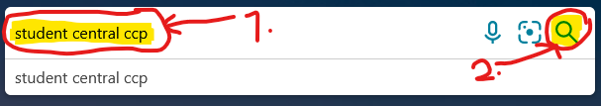

1. Find the first entry that matches ‘Student Central – City College Plymouth’

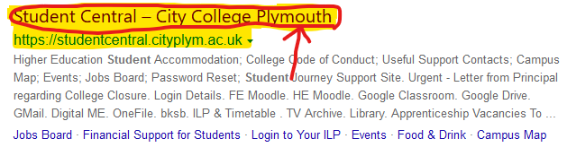

1. Once on Student Central, find the two Moodle tiles. Select FE Moodle if you are a Level 2, 3 or Apprentice (orange lanyard) or HE Moodle if you are Level 4+ (purple lanyard).

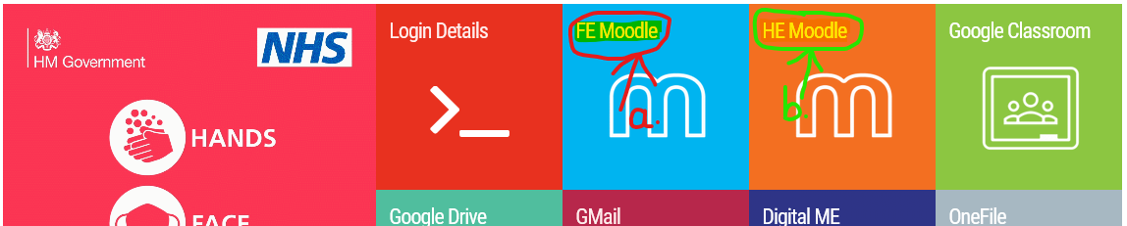

1. After you have clicked the Moodle tile on Student Central, you will be asked to login. Please use your Student number (found on your Student card) as the username, and your College password to access Moodle. If you are unsure what either of these are, contact your tutor.

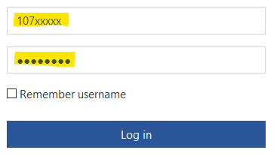

1. Success! You are now logged in! If everything has gone well, you should see the following page:

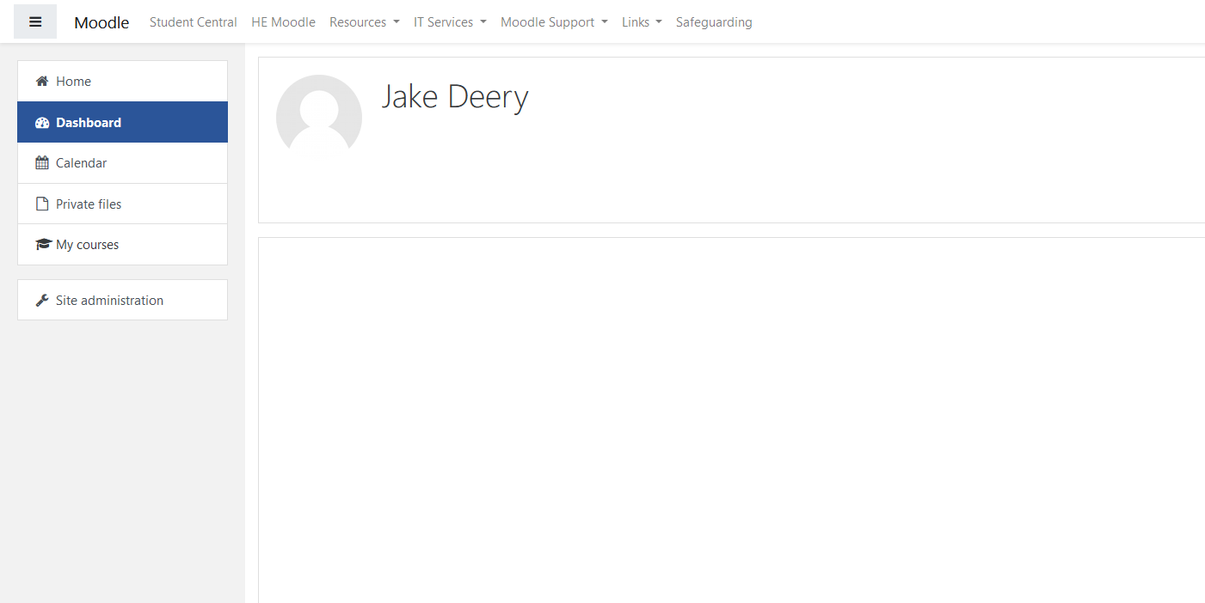

This concludes the contents of this help document. If you have any further queries (i.e. how to access your Moodle course), please contact your tutor who can arrange for your enrolment and a more in-depth tour of the service.